# **TEAM HIKERS**

# **CAPSTONE GROUP PROJECT MILESTONE 1**

The Five Ideas On Which Our Team Wants To Work Upon Are-

1.Exploring AI for its creative uses for the betterment of mankind.

2. Exploring the world of e-commerce to improve online shopping experiences.

3. Investigating the impact of globalization on the environment.

4. Scope of Personalized Healthcare and Mental Well Being.

5. Climate Change Impacts on the Global Food Supply.

**Exploring AI For Its Creative Uses For The Betterment Of Mankind.**

Artificial intelligence is the next big revolution which is changing the world. The world is getting more intelligent day by day. The estimate is that most of the tasks will be performed by AI and machines by the year 2030. Artificial intelligence is a very powerful technology which is changing the world. It is one of the most exciting and promising technologies of the 21st century. Artificial intelligence is affecting various industries including transport, healthcare, ecommerce, etc. It is changing the world in so many ways. It is affecting each domain of life. It is one of the most powerful technologies. It is changing the world by making life easy for human beings.

# **The Problem Statement.**

We as a team want to explore creative uses of AI for the betterment of mankind and want to see a world which is making most out of this powerful technology “AI”.Most people in the World don’t even know how AI is working today in our day to day life with us making our life easier and better.Ultimately one day we will find a balanced use of AI in our life.So the problems we are going to face before getting there and adopting AI are like

1.Lack of experience in the technology.

2.Computing Power (requires great amount of computing power).

3.Trust Deficit (it works on previously fed data to it and finds a pattern in them)

4 The bias problem (the good or bad nature of an AI system really depends on amount of data they are trained on).

5.Data Scarcity

The areas we would like to work as a team on AI are.

* Personalized Shopping.
* AI-Powered Assistants.
* Fraud Prevention.
* Administrative Tasks Automated to Aid Educators.
* Creating Smart Content.
* Voice Assistants.
* Personalized Learning.
* Autonomous Vehicles.

# **Dataset**

. The global artificial intelligence market size is projected to expand at a compound annual growth rate (CAGR) of 37.3% from 2023 to 2030. It is projected to reach $1,811.8 billion by 2030.

. AI is expected to contribute $15.7 trillion to the global economy by 2030, more than the current output of China and India combined.

. The greatest economic gains from AI will be in China which will receive a boost of 26% rise to GDP in 2030, followed by North America (14.5% boost), totalling to $10.7 trillion and accounting for almost 70% of the global economic impact.

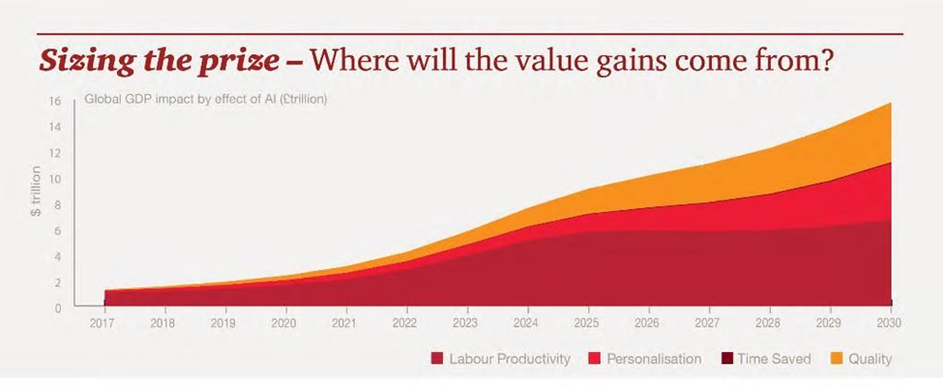

**AI Growth in India**

The demand for AI-based tools and systems is rising across India on account of fast digitization in all the major segments of our economy such as banking and financial services, healthcare, automobile, telecommunication, as AI simply assists in automation, minimizing errors and also helps in managing repetitive tasks. Let’s have a look at some of the important projections which show India to be the leader of AI in future.

* The India artificial intelligence market size reached $ 680 million in 2022 and further it is expected to reach $3,935.5 million by 2028, showcasing a growth rate (CAGR) of 33.28% during 2023-2028.
* AI expenditure in India surged by 109.6% or $ 665 million in 2018 and is estimated to surge at a CAGR of 39% to reach $ 11,781 million by 2025.
* AI has the potential to add close to $500 billion to the country’s GDP by 2025.

# **STRATEGY**

For example, if we work on AI’s role in personalised shopping, we will have the following strategy.

Personalization is a key factor in creating a memorable and engaging shopping experience for our customers. With artificial intelligence (AI), we can leverage data and insights to tailor our merchandising strategies and offer relevant products, recommendations, and content, AI can help us personalize the shopping experience in four ways:

* By segmenting our customers.
* By optimizing our product assortment.
* By creating dynamic pricing and promotions.
* By enhancing our customer service.

The Global AI strategy landscape can be seen below.

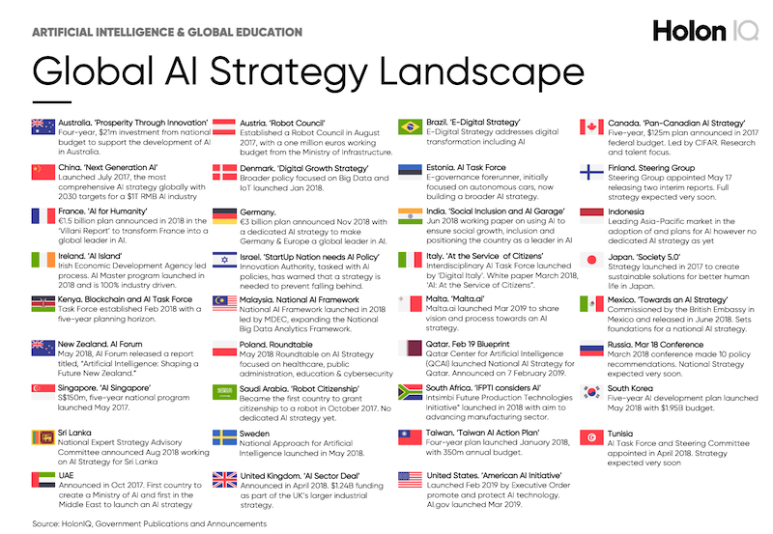

# The values it can bring to the society would be:

AI-powered personalization enables retailers to engage with customers on a more personalized level, providing them with tailored recommendations and promotions that are relevant to their interests and needs.

Other than personalized shopping if we see how AI will bring values to the society are.

* Improved Customer Experience
* **Smarter Decision Making**

### **Research and Data Analysis**

### **Solves Complex Problems**

### **Manages Repetitive Tasks**

### **Reduces Errors**

### **Improved Business Efficiency**

### **Strengthens the Economy**

### **Enhances Lifestyle**

* Disaster Management

# kind of visualization our team is planning to use.

If we work on AI’s role in personalised shopping, we have the following visualization.

**1.Look for the sectors where AI has the maximum and important role playing possibility.**

**2.After finding that we will have our team set up to step in that particular sector.**

**3.As AI is new to us we have a chance to enter the market and make a foothold.**

**Some of the areas we are seeking to invest our potential are:**

* **AI will enable truly personalized medicine (**AI-powered solutions are already being used to improve patient outcomes, reduce healthcare costs, and make healthcare more accessible to people in remote and rural areas.
* **AI in Education.**
* **AI in Home**
* **AI in Transport**

# **A User's Persona**

Name: Dr. Karthik Khanna

Age: 38

Occupation: Environmental Scientist

Background:

- PhD in Climate Science

- Works for a non-profit focused on global environmental solutions

- Passionate about using technology for sustainable solutions

- Often collaborates with tech specialists to integrate AI in her research

Hobbies:

- Nature photography

- Reading sci-fi novels

- Attending tech and environmental conferences

Needs:

- Efficient methods to analyse and interpret vast amounts of data

- Creative solutions to present her findings to the public and stakeholders

- Tools to predict future environmental trends

A user story.

As Dr. Karthik Khanna, I want to use AI's creative ability to analyse vast amounts of climate data, so I can quickly identify patterns that may not be apparent to the human eye. This would allow me to predict future environmental changes, develop strategies to prevent negative impacts. By harnessing AI's capabilities, I hope to inspire and guide humanity towards a more sustainable future.

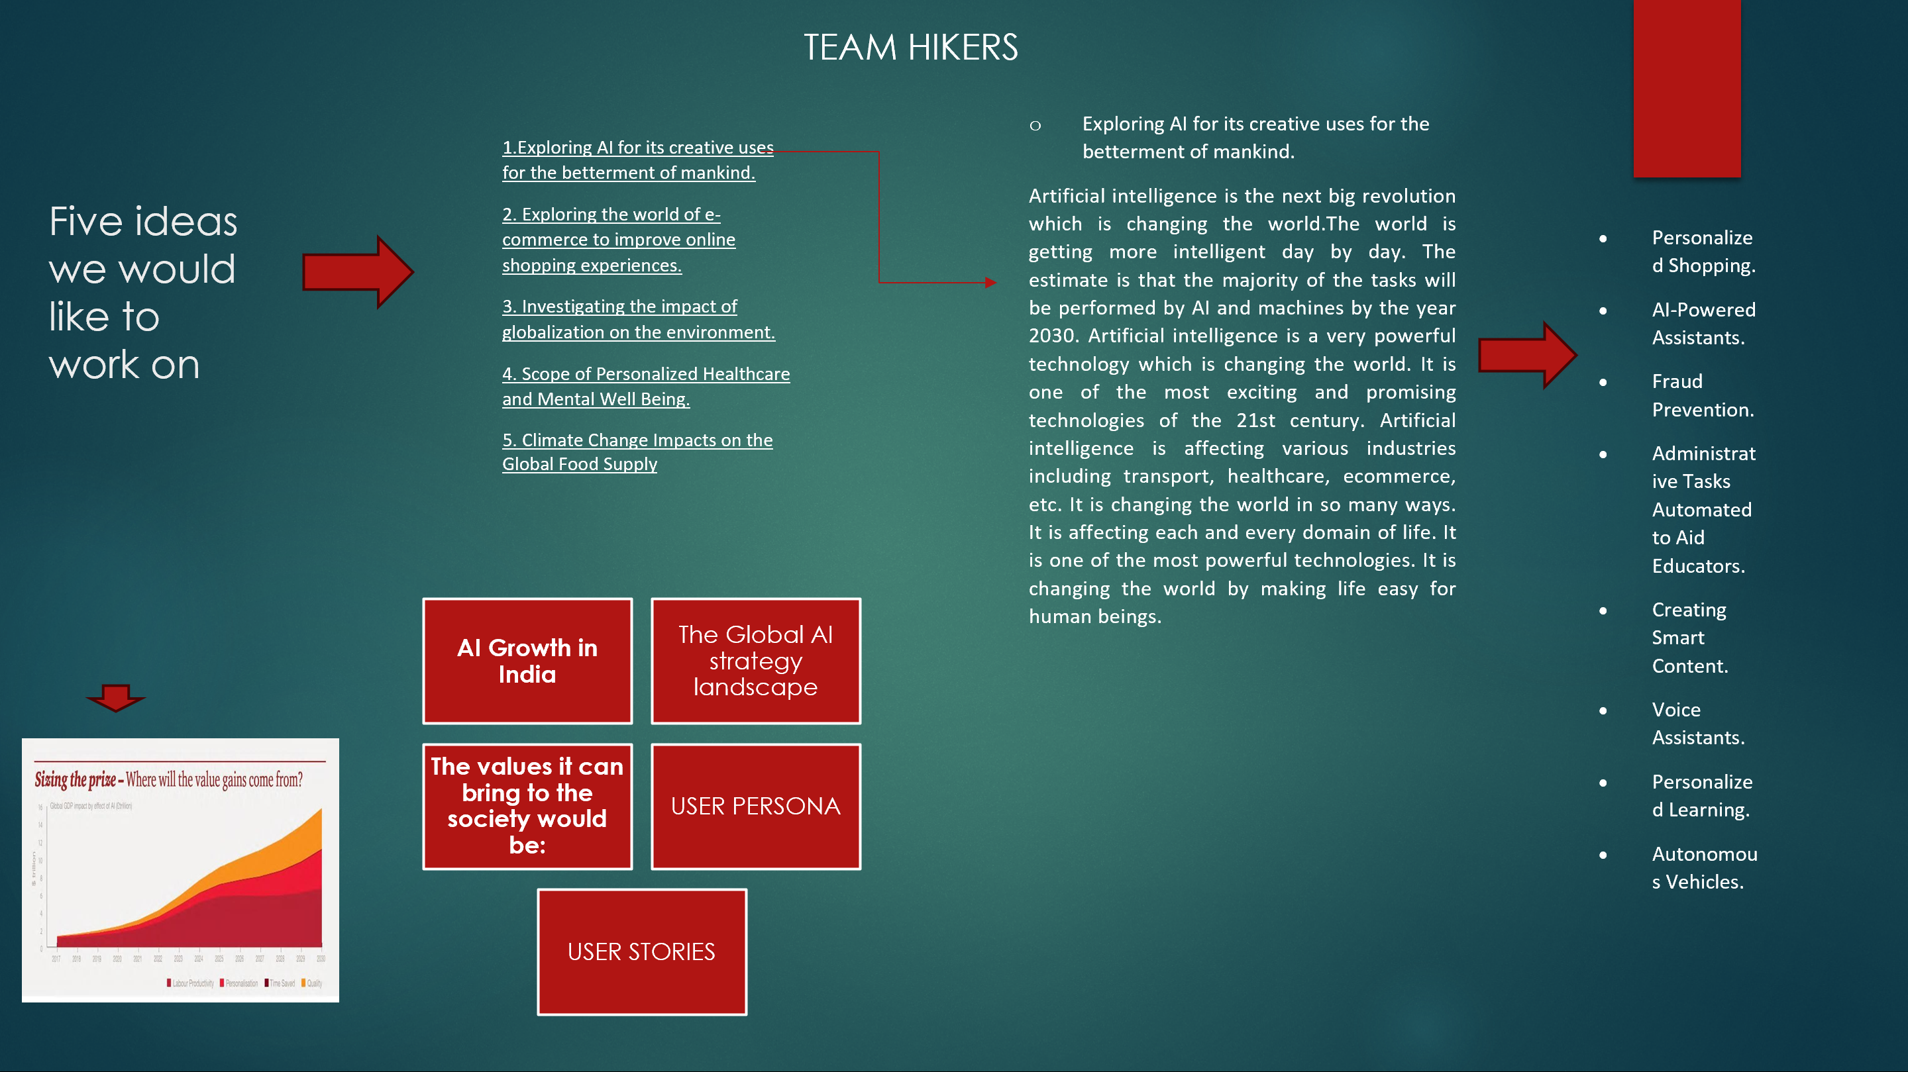

This project is submitted by the following members of the team-HIKERS-

|  |  |
| --- | --- |
| *Muskan* | *PGD202347535* |
| *Prakash Thakur* | *PGD202344870* |
| *Abhishek Sharma* | *PGD202345428* |
| *Kartik Rathore* | *PGD202340308* |
| *Ritwik Dayal Singh* | *PGD202347215* |
| *Vaibhav Chauhan* | *PGD202350336* |
| *Manisha Pal* | *PGD202350157* |
| *Akshit Gupta* | *PGD202342224* |